M.Abdullah.Mahmood
BCS – 3B
22F – 3289
To : Sir Saqib
DSA lab 8
Task 1 :
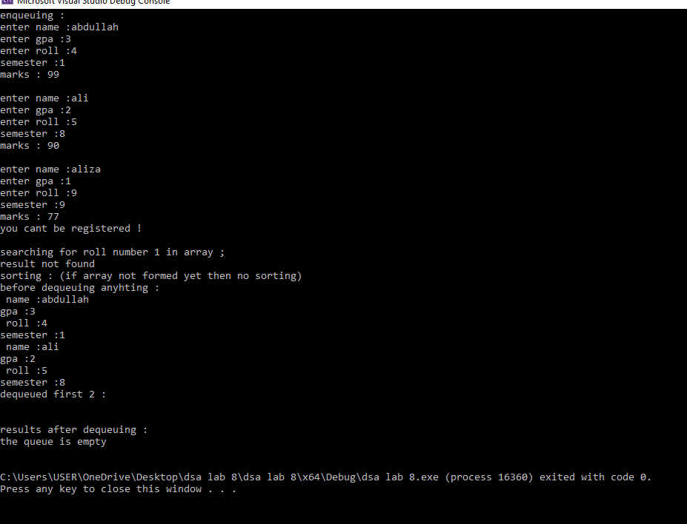
#include<iostream>
#include<vector>
using namespace std;

class node{
public:
int roll, sem, marks, gpa;
string name;
node* next;

node() {
next = nullptr;
}
node(int r, int s, int m, int g, string n) {
roll = r;
sem = s;
marks = m;
gpa = g;
name = n;
next = nullptr;
}

~node() {};
};

class queue {
public:
int num = 0 , numq = 0;
int arr[50] = { 0 };
int iterator = 0;

node* head,*tail;
queue() : head(nullptr), tail(nullptr) {};

void enque() {

string name;
int marks, gpa, roll, sem;

cout << "enter name :";
cin >> name;
cout << "enter gpa :";
cin >> gpa;
cout << "enter roll :";
cin >> roll;
cout << "semester :";
cin >> sem;
cout << "marks : ";
cin >> marks;

if (gpa < 2) {
cout << "you cant be registered !\n";
return ;
}

node* temp = new node(roll, sem, marks, gpa, name);

if (head == NULL) {
head = temp;
tail = temp;
}
else {

if (full()) {
return;
}

if (numq <= 1) {
tail->next = temp;
tail = temp;
}
else {

/*arr[iterator] = head->roll;
temp->next = head->next;
head = temp;
tail = temp;*/

node* cur = head;
while (cur) {
arr[iterator] = deque();
}

head = temp;
tail = temp;

}
}

++num;

if (num > 10)
numq++;
return;
}

int deque() {
--num;
empty();
node* temp = head;
head = head->next;
return temp->roll;
}

void bubblesort() {
bool swapped;
for (int i = 0; arr[iterator]!=0 && i<50 ; i++) {
swapped = false;
for (int j = 1; j < 50; j++) {
if (arr[j] > arr[j + 1]) {

int temp = arr[j];
arr[j] = arr[j + 1];
arr[j + 1] = temp;
swapped = true;
}
}

if (!swapped) {
break;
}
}
}

void search(int r) {
for (int i = 0; arr[iterator] != 0; ++i) {
if (arr[iterator] == r) {
cout << "result found";
return;
}
}

cout << "result not found \n";
return;
}

bool full() {
if (numq == 2) {
cout << "queue is full , cant insert more entries \n";
return true;
}
return false;
}

bool empty() {
if (head == NULL) {
cout << "the queue is empty \n";
return true;
}
return false;
}

void display() {

if (empty()) {
return;
}

node* temp = head;
while (temp) {

cout << " name :" << temp->name << endl;
cout << "gpa :" << temp->gpa << endl;
cout << " roll :" << temp->roll << endl;
cout << "semester :" << temp->sem << endl;

temp = temp->next;
}
return;
}

~queue() {};
};

int main()
{
int dequeuedresults[10] = {0};
queue q1;
cout << "enqueuing : \n";
q1.enque();
cout << endl;
q1.enque();
cout << endl;
q1.enque();
cout << endl;

cout << "searching for roll number 1 in array ; \n";
q1.search(1);

cout << "sorting : (if array not formed yet then no sorting)\n";
q1.bubblesort();

cout << "before dequeuing anyhting : \n";
q1.display();

cout << "dequeued first 2 : \n";

for (int i = 0; i < 2; ++i) {
dequeuedresults[i] = q1.deque();
cout << endl;
}

cout << "results after dequeuing :\n";
q1.display();
cout << endl;

return 0;
}

Task 3 :
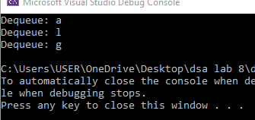
#include <iostream>
using namespace std;

class ArrayQueue {
private:
char* stack1;
char* stack2;
int capacity;
int top1;
int top2;

public:
ArrayQueue(int size) {
capacity = size;
stack1 = new char[size];
stack2 = new char[size];
top1 = -1;
top2 = -1;
}

~ArrayQueue() {
delete[] stack1;
delete[] stack2;
}

void enqueue(char item) {
if (top1 >= capacity - 1) {
top1 = 0;
stack1[top1] = item;
cout << "Queue is full. Overwriting queue." << endl;
}
else {
stack1[++top1] = item;
}
}

char dequeue() {
if (top2 == -1) {
if (top1 == -1) {
cout << "Queue is empty. Cannot dequeue." << endl;
return '\0';
}
else {
while (top1 >= 0) {
stack2[++top2] = stack1[top1--];
}
}
}
return stack2[top2--];
}
};

int main() {
ArrayQueue queue(10);

queue.enqueue('a');
queue.enqueue('l');
queue.enqueue('g');

cout << "Dequeue: " << queue.dequeue() << endl;

queue.enqueue('o');
queue.enqueue('r');
queue.enqueue('i');
queue.enqueue('t');
queue.enqueue('h');
queue.enqueue('m');

cout << "Dequeue: " << queue.dequeue() << endl;
cout << "Dequeue: " << queue.dequeue() << endl;

return 0;
}

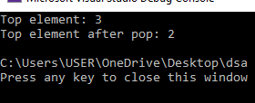
#include <iostream>
#include <queue>
using namespace std;

class StackUsingQueues {
private:
queue<int> q1;
queue<int> q2;

public:

void push(int x) {
q2.push(x);
while (!q1.empty()) {
q2.push(q1.front());
q1.pop();
}
swap(q1, q2);
}

void pop() {
if (!q1.empty()) {
q1.pop();
}
}

int top() {

if (!q1.empty()) {
return q1.front();
}
return -1;
}

bool empty() {
return q1.empty();
}
};

int main() {
StackUsingQueues stack;
stack.push(1);
stack.push(2);
stack.push(3);

cout << "Top element: " << stack.top() << endl; // Output: 3

stack.pop();

cout << "Top element after pop: " << stack.top() << endl; // Output: 2

return 0;
}

